Block Diagram

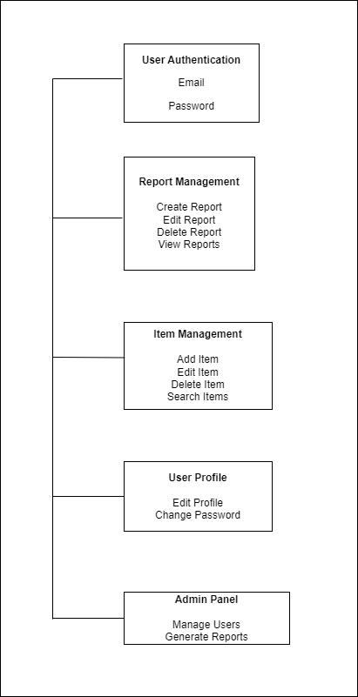

System Flowchart

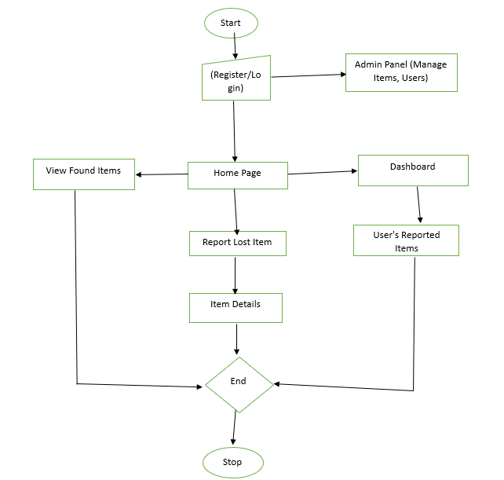

Program Flowchart

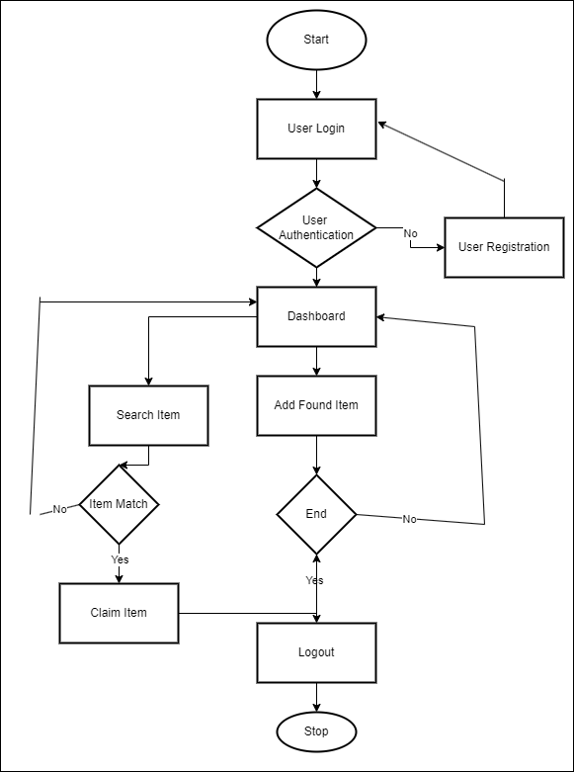

Modular Program Flowchart

**User Interface Module**

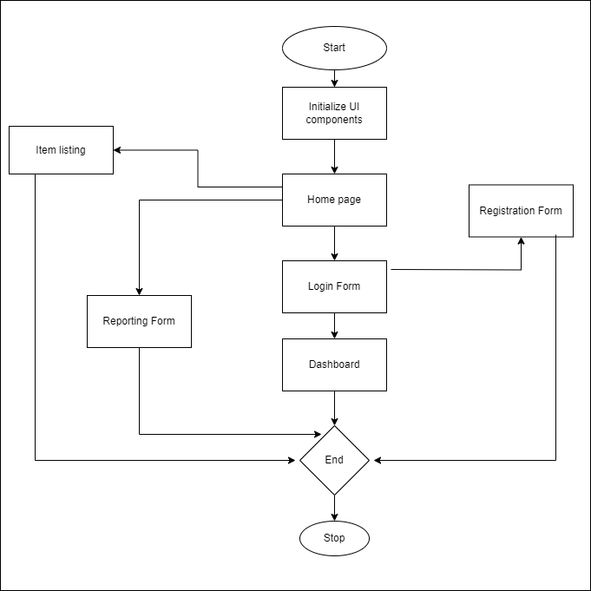

**User Authentication Module**

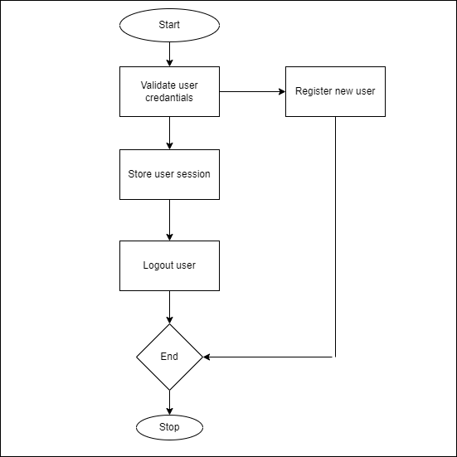

**Reporting Module**

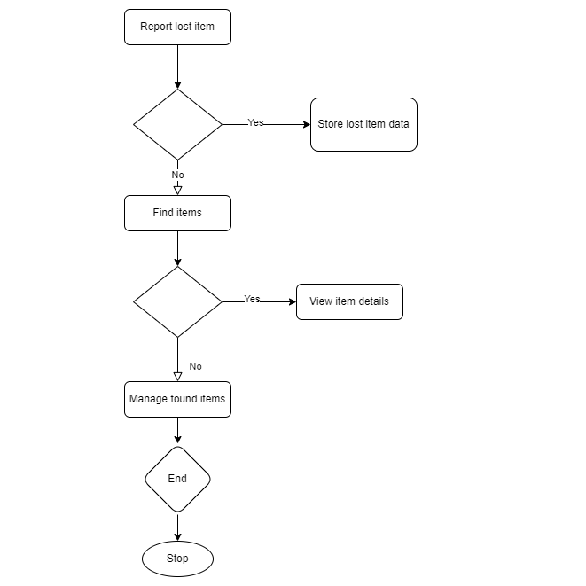

**User Profile Module**

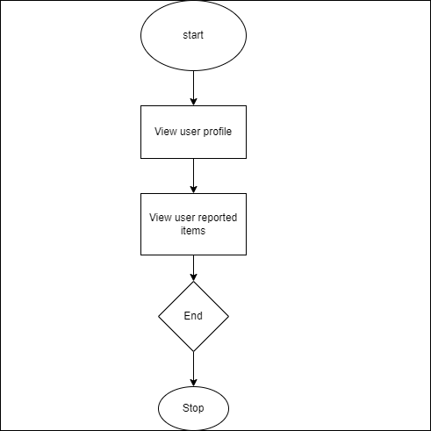

**Admin Module**

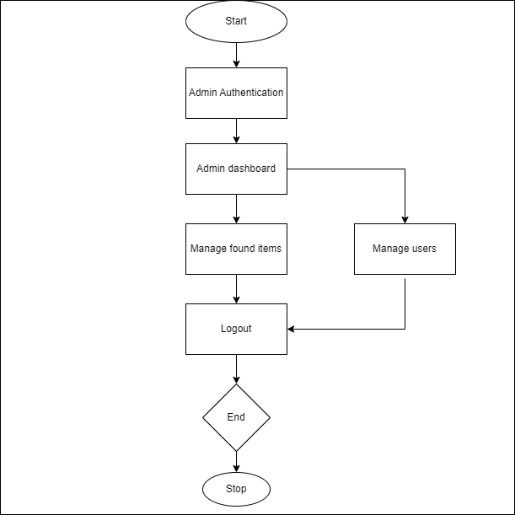

**CLASS DIAGRAM**

**User**

- userId: String

- username: String

- password: String

- email: String

+ getUsername(): String

+ getEmail(): String

+ setPassword(password: String): void

1,1

1,1

1,* 1,*

**Found item**

- itemId: String

- description: String

- location: String

- dateFound: Date

- finder: User

+ getItemId(): String

+ getDescription(): String

+ getLocation(): String

+ getDateFound(): Date

**Lost item**

- itemId: String

- description: String

- location: String

- dateLost: Date

+ getItemId(): String

+ getDescription(): String

+ getLocation(): String

+ getDateLost(): Date

+ isClaimed(): boolean

1,*

1,*

**Customer support**

- supportId: String

- email: String

- phone: String

|

+ getSupportId(): String

+ getEmail(): String

+ getPhone(): String

+ provideSupport(contactDetails: ContactDetails): string

**DATAFLOW DIAGRAM**

User acc. DB

authentication

Upload item

user uploads items

login

user

login

s details admin verifies items

Items DB

Store found items

Verify items uploaded

Login details

admin

Retrieve lost items

Search for items

Find item

**USE CASE DIAGRAM**

Verify password

<<include>>

login

user admin

Verify items

Upload item

<<include>>

<<include>>

Display found items

Find item

User login

Valid user

no

Registration

**ACTIVITY DIAGRAM**

yes

Upload item

no

yes

Enter item details

no

yes

Admin verification

View item